**PROJECT REPORT**

## on

**PROMOTING**

**ORGANIC FARMING**

**(CSE VI Semester Mini project)**

**2021-2022**



**Submitted to:**

Mr. SATVIK VATS

(CC-CSE-B-VI- Sem)

**Submitted by:** Mr.Rishabh Negi

Roll. No.:1918910

CSE-B-VI-Sem

Session: 2020-2021

**DEPARTMENT OF COMPUTER SCIENCE AND ENGINEERING**

**GRAPHIC ERA HILL UNIVERSITY, DEHRADUN**

# **CERTIFICATE**

Certified that Mr. Rishabh Negi (Roll No.- 1918910) has developed mini project on “Promoting Organic Farming” for the CS VI Semester Mini Project Lab (PCS-604) in Graphic Era Hill University, Dehradun. The project carried out by Student is his own work as best of my knowledge.

(Mr. Satvik Vats) (Rishabh Negi)

**Class Co-ordinator Student**

**CSE-B-VI-Sem CSE-B-VI-Sem**

(CSE Department) (CSE Department)

GEHU Dehradun GEHU Dehradun

**ACKNOWLEDGMENT**

I would like to express our gratitude to The Almighty, the most beneficent and the most merciful, for completion of the project. I wish to thank my parents for their continuing support and encouragement. I also wish to thank them for providing me with the opportunity to reach this far in our studies.

I would like to appreciate My Professors for their patience, support and encouragement throughout the completion of this project and for having faith in me.

## Rishabh Negi

## Roll No.- 1918910

## CSE-B-VI-Sem

**Session: 2021-2022**

**TABLE OF CONTENTS**

### ABOUT PROJECT

* 1. Objective

### ORGANIC FARMING

* 1. Definition
     1. Characteristics
     2. Effects Of Modern Farming

### METHODOLOGIES / TECHNIQUES

* 1. Techniques Adopted

3.1.1 Soil Management

3.1.2 Weed Management

3.1.3 Crop Diversity

3.1.4 Chemical Management

3.1.5 Biological Pest Control

* 1. Advantages

1. **CONSTRAINTS AND CHALLENGES**

4.1 Lack Of Awareness

4.2 Output Marketing Problems

4.3 Shortage of Bio-mass

4.4 Inadqaute supporting Infrastructure

4.5 High Input Cost

### IMPLEMENTATION

* 1. About Page
  2. Producers Helping Page
  3. Consumer Buying Page
  4. Technology Used

1. **REFERENCES**
2. **ABOUT PROJECT**
   1. Objectives of the Project

* To understand the need for organic farming in India in the light of the experiences of other countries.
* To assess and evaluate the factors which may facilitate the adoption of organic farming in the country.
* To analyse the constraints, both political and social, and above all economic, in the introduction of organic farming in India.

1. **ORGANIC FARMING**
   1. **Defintion**

Agriculture in an organic way involves the use of many non-chemical inputs like manure, compost, animal manure, plants and trees, fruits and vegetables, etc. It should be noted that the production of foodstuff needs lots of inputs, which will be consumed in the form of fertilizer, insecticides, pesticides, etc. These chemicals do no good to the soil and ultimately they are stored in the water, which has to be cleaned and treated regularly. So, the key point of agriculture in an organic way is to increase the biological productivity in the agricultural field and this can be achieved with the help of biological products like manure, compost, animal dung, etc.

Agriculture inorganic way does not involve any release of surplus product as in conventional farming. This means that there will be a very little left after the food is being grown. This also helps to conserve the land and to preserve the natural resources of the soil. In addition, there is less use of land for agricultural production of feed, medicines, and foodstuffs as animals are not used for this purpose.

“It is agricultural production system which avoids or largely excludes the use of synthetically compounded fertilizers, pesticides, growth regulators and livestock feed additives. To the maximum extent feasible organic farming system rely upon crop rotation, crop residues, and animal manure, legumes, green manure, mineral-bearing rocks and aspects of biological pest control to maintain soil productivity and tilth to supply plant nutrients and to control insects, weeds and other pests”.

“Organic farming is a system which avoids or largely excludes the use of synthetic inputs (such as fertilizers, pesticides, hormones, feed additives etc.) and to the maximum extent feasible rely upon crop rotations, crop residues, animal manures, off-farm organic waste, mineral grade rock additives and biological system of nutrient mobilization and plant protection”.

**2.1.1 Characteristics of Organic Farming include**:

1. Protecting the long term fertility of soils by maintaining organic matter levels, encouraging soil biological activity, and careful mechanical intervention;
2. Providing crop nutrients indirectly using relatively insoluble nutrient sources which are made available to the plant by the action of soil micro­organisms;
3. Nitrogen self-sufficiency through the use of legumes and biological nitrogen fixation, as well as effective recycling of organic materials including crop residues and livestock manures;
4. Weed, disease and pest control relying primarily on crop rotations, natural predators, diversity, organic manuring, resistant varieties and limited (preferably minimal) thermal, biological and chemical intervention;
5. The extensive management of livestock, paying full regard to their evolutionary adaptations, behavioral needs and animal welfare issues with respect to nutrition, housing, health, breeding and rearing;
6. Careful attention to the impact of the farming system on the wider environment and the conservation of wildlife and natural habitats.

**2.1.2 Affects of Modern Farming Technology**

The role of agriculture in economic development in an agrarian country like India is a pre-dominant one. Agriculture provides food for more than 1 billion people and yields raw materials for agrobased industries. Agricultural exports earn foreign exchange. Modernization of Indian agriculture began during the mid-sixties which resulted in the green revolution making the country a foodgrain surplus nation from a deficit one depending on food imports. Modern agriculture is based on the use of high yielding varieties of seeds, chemical fertilizers, irrigation water, pesticides, etc., and also on the adoption of multiple cropping systems with the extension of area under cultivation. But it also put severe pressure on natural resources like, land and water. However, given the continuous growth of modern technology along with the intensive use of natural resources, many of them of non renewable, it is felt that agriculture cannot be sustainable in future because of the adverse changes being caused to the environment and the ecosystem. The environmental non-degradable nature of the agricultural development and its ecological balance have been studied in relation to the modem Indian farming system by experts which shows exploitation of land and water for agriculture, and the excessive use of chemicals.

Chemical Contamination

Fertilizers: Consumption of chemical fertilizers {N,P,K) has been increasing in India during the past thirty years at a rate of almost half a million tonnes on an average, a year. It was only 13.13 kg/ha in 1970-71, 31.83 kg/ha in 1980-81 and 74.81 kg/ha in 1995-96. It shot up to about 96 kg/ha during 1999-2000. Table 5 shows the consumption of fertilizers in India from 1970-71 to 2001-02.

Pesticides:

The use of chemical pesticides began with the discovery of toxicological properties of DDT and HCH during the Second World War. Many chlorinated hydrocarbon insecticides like aldrin, dieldrin, toxaphane, chlordane, endosulfan, etc. came into the market during the second half of the last century. Simultaneously, organophosphate and carbonate compounds were employed in agriculture. A new group of insecticides, such as premethrin, cypermethrin, fenalerate, etc. which were effective at low doses came into being in the 1970s.

Salinity and Water logging :

Water is one of the important inputs for the vigorous growth and high yields of crops. The modernisation of Indian agriculture has resulted in the increased use of irrigation water. The area under irrigation has grown substantially during the past three decades.

Depletion of Energy Resources:

Chemical fertilizers, pesticides, herbicides, etc are manufactured using the non-renewable materials like the fossil fuels. The global demand for oil and natural gas is increasing and thus the price of the inputs to agriculture is bound to rise. India's petroleum resources, which presently meet only about 30-35 per cent of the consumption demand, are under pressure. Increasing demand for chemicals and energy in agriculture sector will have affects on our energy sources. The investments in agriculture have to be increased to meet the rising input costs and larger areas are brought under farming to earn profits. Large farms have to transport the produce to distant areas. Again, energy will be required for transportation, processing and packaging. The rice-wheat cropping pattern and the cultivation of crops like sugarcane require high irrigation, which results in the depletion of water level. Singh and Singh (1996) found that the water level in the states of Punjab and Haryana had gone down by 0.3 to 1 m per annum during a period of 10 years due to the excessive use of water for paddy crop.

Input-Output Imbalance:

A crop, in its growth process, incorporates a part of the soil fertility into the parts of the plant. The roots remain in the soil. The leaves and stems are fed to the cattle/burnt as fuel/directly 38 returned to the soil. The consumed part by cattle and human also go back to the soil. The practice of commercial farming leads to continuous export of the soil fertility to outside the farming areas as the organic matter leaves the locality. The soil nutrients in the form of farm produces continue to be exported. The import of chemical fertilizers cannot compensate the loss of soil nutrients through exports. The soil becomes powdery and gets eroded by wind or rain. If the harvests are exported from the country, the loss is higher (Anon, 1996). The Earth can produce only a limited amount of biomass from a given area. If man tries to extracj: more, the system degenerates. If we realize that we live in a closed eco-system and act in tune, the resources can be used iri a sustainable way. The maintenance of a dynamic equilibrium balances the inputs and outputs in a region. If agriculture becomes unsustainable, no society can survive for a long time. Expansion of Cultivated Area Not only the intensive cultivation through the use of technological inputs, but also the extensive crop production through Increase in the area under cultivation has been an important aspect of modern agriculture seen in India. Increasingly areas under forests are brought under plough along with the marginal, sub-marginal and undulating land. The net sown area was 140 million ha in 1970- 71 and stood at 142 million ha at the end of 1997-98. Reduction in Genetic Diversity The genetic base of crops is very important and a reduction of genetic diversity leads to the emergence of pests on a large scale. Farmers, in olden times, apart from' using the crop rotation methods to maintain the soil fertility also relied on the genetic means to increase crop production. Relying exclusively on nation's own reserves of fertility and immunology, the farming community by evolving trial and error methods discovered. hybrid varieties of crops by crossing the related strains. These crosses were from the same environment and no violence was used to separate them from nature by maintaining the ecological balance

### 3.1 Techniques of Organic farming

There are some techniques by which organic farming in India practiced. Check out below the methods of organic farming in India.

#### 3.1.1 Soil Management

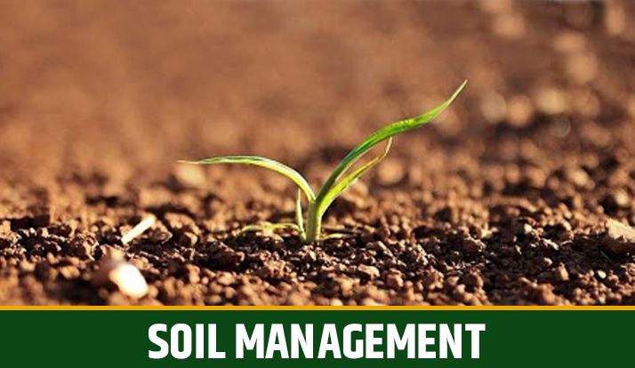

Soil management is the primary technique of organic farming in India. After cultivation, soil loses its nutrients, and its fertilizer goes down. The process in which soil is recharging with all the necessary nutrients called soil management. Organic farming uses natural ways to increase the fertility of the soil. It uses bacteria, available in animal waste. The bacteria helps in making the soil more productive and fertile.Soil Management is first in the organic farming methods list.

#### 3.1.2. Weed Management

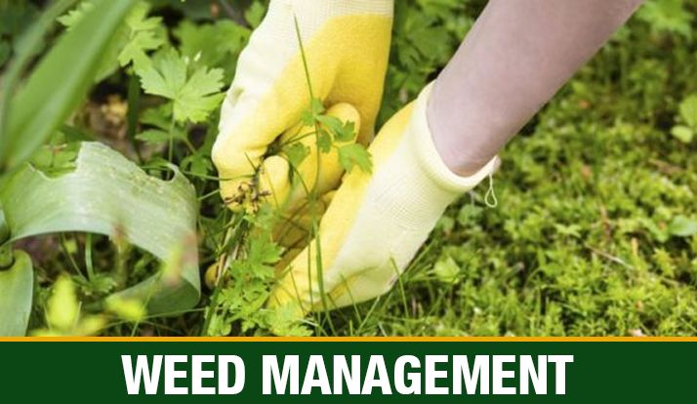

Organic farming’s main aim is to remove the weeds. Weeds are the unwanted plant, growing with the crop. Weeds Sticking with nutrients of the soil affected the production of the crops.

There are two techniques which give a solution to the weed.

* **Moving or cutting** – In this process, cut the weed.
* **Mulching** – In this process, farmers use a plastic film or plant to residue on the soil’s surface to block the weed’s growth.

#### 3.1.3. Crop Diversity

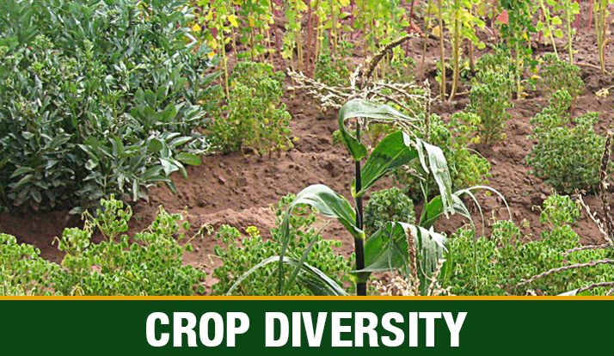

According to this technique, different crops can cultivate together to meet the growing demand for crops.Crop diversity is one of the most famous organic farming techniques in India.

#### 3.1.4. Chemical Management in Farming

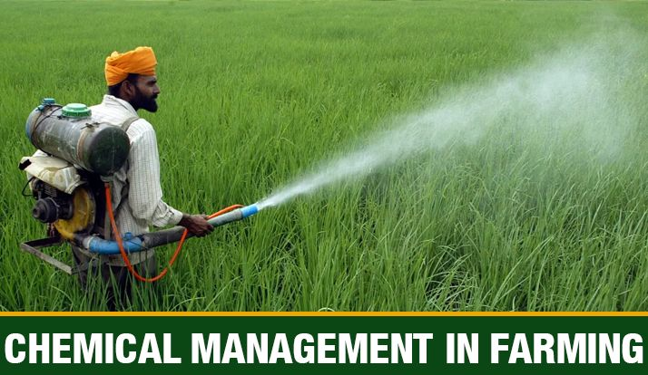

Agricultural farms contain useful and harmful organisms that affect farms. To save crops and soil, the growth of organisms needs to be controlled. In this process, natural or fewer chemicals, herbicides, and pesticides used to protect soil and crops. Proper maintenance is required throughout the area to control other organisms.

#### 3.1.5. Biological Pest Control

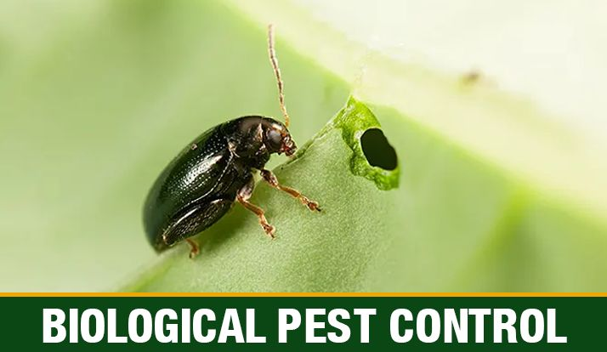

In this method, use living organisms to control pests with or without the use of chemicals. These techniques of organic farming are followed by Indian farmers in agriculture.

#### **3.2 Advantages of Organic Farming**

* Organic farming in India is very economical, it uses no expensive fertilizers, pesticides, HYV seeds for the plantation of crops. It has no expenses.
* With the use of cheaper and local inputs, a farmer can earn a good return on investment. This is one of the most important benefits of organic farming in India.
* There is a huge demand for organic products in India and worldwide and can earn more income through export.
* Organic products are more nutritional, tasty, and good for health to chemical and fertilizer utilized products.
* Organic farming in India is very environment friendly, it does not use fertilizers and chemicals.

These are some benefits of Organic Farming, which proves organic farming is profitable for everyone. We need to spread awareness about the advantages of organic farming in India to encourage Organic farming.

**4. Major Problems and Constraints for Organic Farming in India!**

#### 4.1 Lack of Awareness:

The most important constraint felt in the progress of organic farming is the inability of the government policy making level to take a firm decision to promote organic agriculture.

Unless such a clear and unambiguous direction is available in terms of both financial and technical supports, from the Centre to the Panchayat levels, mere regulation making will amount to nothing. Many farmers in the country have only vague ideas about organic farming and its advantages as against the conventional farming methods.

Use of bio-fertilizers and bio pesticides requires awareness and willingness on the part of the farming community. Knowledge about the availability and usefulness of supplementary nutrients to enrich the soil is also vital to increase productivity. Attention on the application of composts/organic manure is also lacking.

The organic matter is spread during the months when the right moisture level is absent on the soil. The whole manure turns into wastes in the process. The required operation is of course labour intensive and costly, but it is necessary to obtain the desired results.

#### 4.2 Output Marketing Problems:

It is found that before the beginning of the cultivation of organic crops, their marketability and that too at a premium over the conventional produce has to be assured. Inability to obtain a premium price, at least during the period required to achieve the productivity levels of the conventional crop will be a setback.

#### 4.3 Shortage of Bio-mass:

Many experts and well informed farmers are not sure whether all the nutrients with the required quantities can be made available by the organic materials. Even if this problem can be surmounted, they are of the view that the available organic matter is not simply enough to meet the requirements.

#### 4.4 Inadequate Supporting Infrastructure:

In spite of the adoption of the NPOP during 2000, the state governments are yet to formulate policies and a credible mechanism to implement them. There are only four agencies for accreditation and their expertise is limited to fruits and vegetables, tea, coffee and spices. The certifying agencies are inadequate.

#### 4.5 High Input Costs:

The small and marginal farmers in India have been practicing a sort of organic farming in the form of the traditional farming system. They use local or own farm renewable resources and carry on the agricultural practices in an ecologically friendly environment. However, now the costs of the organic inputs are higher than those of industrially produced chemical fertilizers and pesticides including other inputs used in the conventional farming system.

#### 4.6 Marketing Problems of Organic Inputs:

Bio-fertilizers and bio-pesticides are yet to become popular in the country. There is a lack of marketing and distribution network for them because the retailers are not interested to deal in these products, as the demand is low. The erratic supplies and the low level of awareness of the cultivators also add to the problem.

Higher margins of profit for chemical fertilizers and pesticides for retailing, heavy advertisement campaigns by the manufacturers and dealers are other major problems affecting the markets for organic inputs in India.

#### 4.7 Low Yields:

In many cases the farmers experience some loss in yields on discarding synthetic inputs on conversion of their farming method from conventional to organic.

Restoration of full biological activity in terms of growth of beneficial insect populations, nitrogen fixation from legumes, pest suppression and fertility problems will take some time and the reduction in the yield rates is the result in the interregnum. It may also be possible that it will take years to make organic production possible on the farm.

**5. IMPLEMENTATION**

The project will contain different pages or we can say features associated with Organic farming. The project will have 2 sections One for producers and other for consumers

About Page: In order to Promote what is Organic Farming, why is it important than non-organic farming and its methodologies to the peoples which are not aware about its benefits

Help Option Page: In order to provide help the individuals or a group of Producers both socially or economically from experts in agricultural fields

Buying Page: In order to present variety of organic vegetables and froots for Consumers and checkout option to buy such organic products online with a home delivery option.

5.4 TECHNOLOGY USED :

HTML5, CSS3, Flexbox, Fluid Layout, JavaScript , jQuery , animation effects , React Js

**REFERENCE**

* 1. Organic Farming in INDIA: RELEVANCE, PROBLEMS AND CONSTRAINTS BY DR. S. NARAYAAN

# Article on Organic farming in India: a vision towards a healthy nation by By Das, Suryatapa.

* 1. OFAI The Organic Farming Association Of INDIA
  2. ©IFOAM - Organics International, 2021